● Fetch date and temperature from temperature_data where zip code is greater than 300000 and less than 399999.

To achieve the problem statement we have used the custom database created and the table temperature_data is created with required columns. The data is loaded in the table from the given database. Then the select statement is used to fetch the required columns with the given condition for the zipcode which is implemented on the where clause.

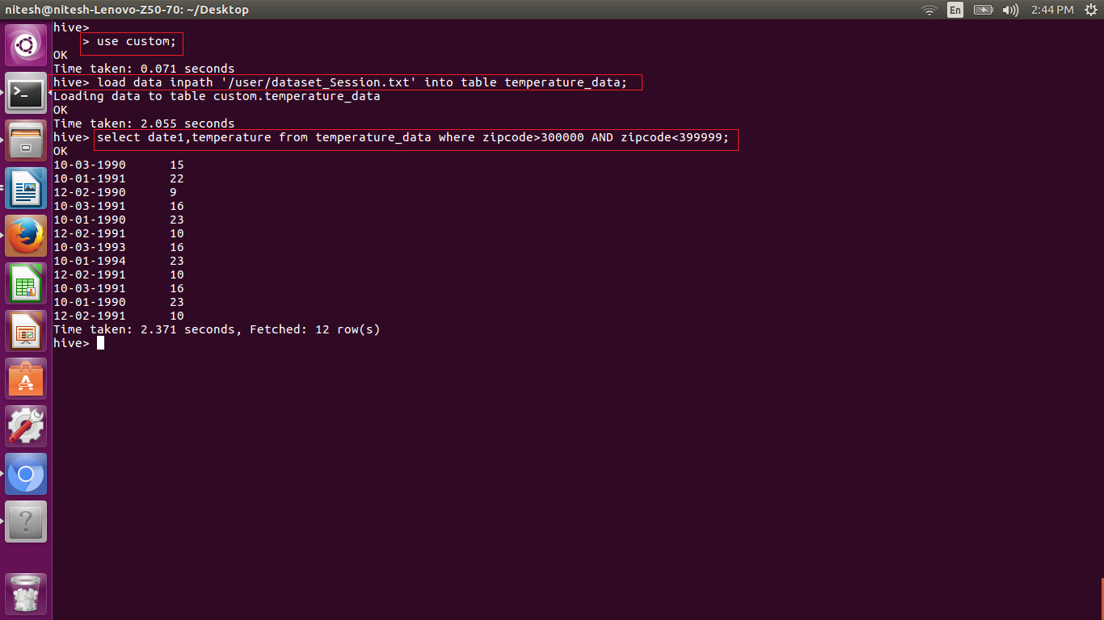

● Calculate maximum temperature corresponding to every year from temperature_data table.

Here we want to get the maximum temperature for every year for this we used MAX keyword to get the maximum temperature from the group of years to get the required fields.

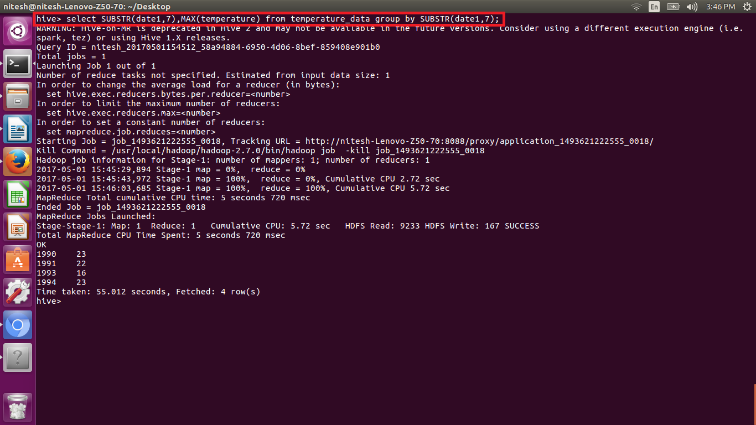

● Calculate maximum temperature from temperature_data table corresponding to those years which have at least 2 entries in the table.

Here we want to get the maximum temperature for every year for this we used MAX keyword to get the maximum temperature from the group of years to get the required fields. Also we need to check the number of enteries for the years so we implemented the having clause to get the count and check the required condition.

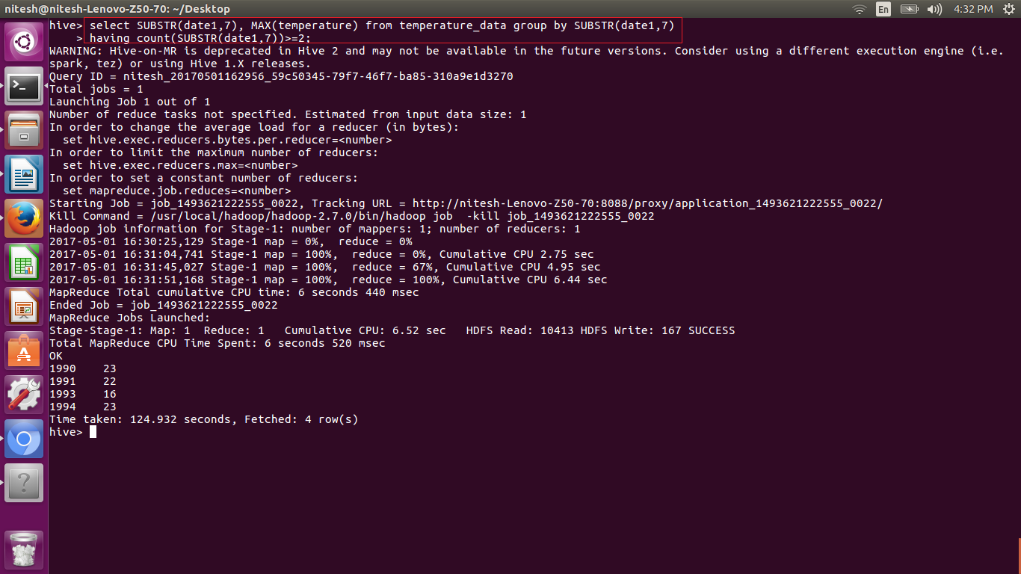

● Create a view on the top of last query, name it temperature_data_vw.

View is used to hold the data temporarily and it does not hold the data permanent. The following query is used to create view.

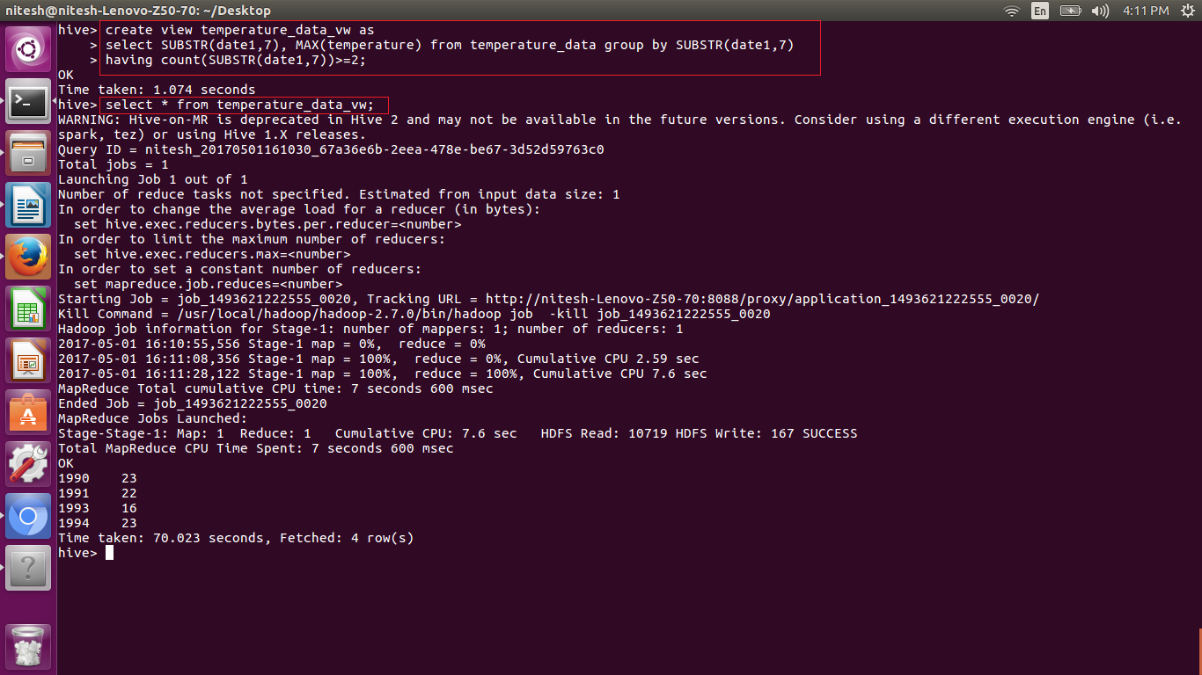

● Export contents from temperature_data_vw to a file in local file system, such that each file is '|' delimited.

Here the created view holds the data year and the temperature in the few columns and we need to export it to the local system. For this we use the command insert overwrite local ‘path’ deliminator;

